Url Slug Suggestion - https://rootcabs.com/taxi-in-tiruppur
Primary Keyword
taxi in tiruppur
taxi service in tiruppur
taxi services tiruppur

Secondary Keyword
one way drop taxi tirupur
cab booking tirupur
cab booking in tirupur
call taxi in tiruppur
coimbatore airport to tirupur taxi
best cab services in tiruppur
Page Layout

H1 - Taxi Service in Tiruppur - Banian City & Coimbatore Airport Cabs

H2 - Fare Calculator
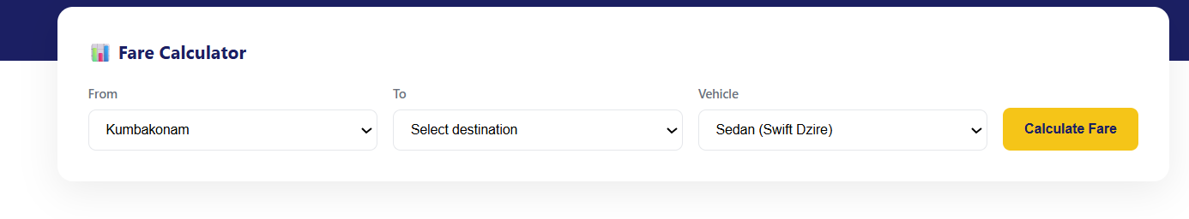

H2 - Services Available in Tiruppur


H2 - Popular Routes from Tiruppur (Define the header in two lines below this header)
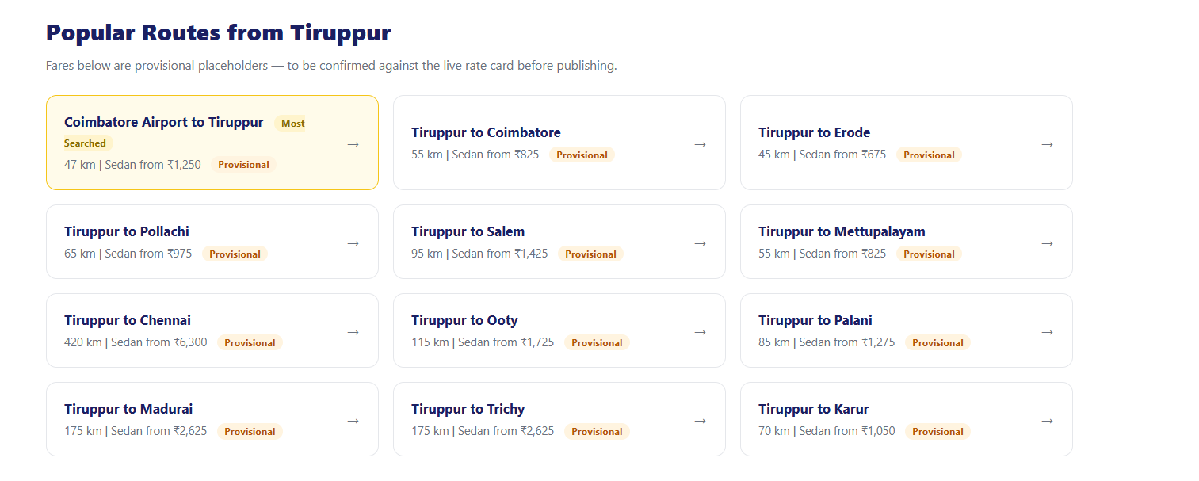

H2 - Popular Pickup Spots In Tiruppur
Define the header in two lines below this header


H2 - Tiruppur - India's Banian City & Knitwear Capital
H3 - Avinashi Lingeshwarar Temple
H3 - Thirumoorthy Dam
H3 - Sivanmalai
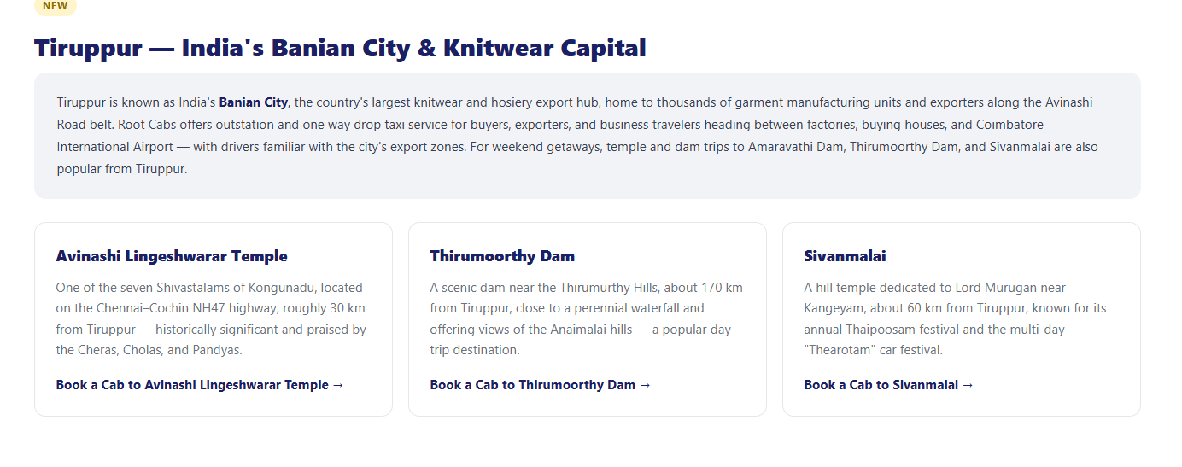

H2 - Customer Reviews in Tiruppur (write three customer reviews )



H2 - Why Choose Root Cabs in Tiruppur?

H2 - Driving With Root Cabs in Tiruppur
H3 - Become a Driver Partner
H3 - Need an Acting Driver?


Acting driver section added - Purpose interlinking to the acting driver page.


H2 - Frequently Asked Questions
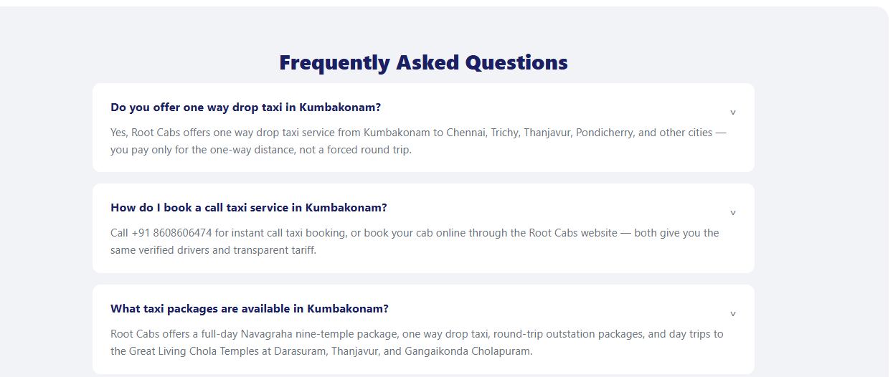
Is there a minimum distance for one way drop taxi in Tiruppur?
What is the fare for Tiruppur to Ooty taxi?
Do you provide taxi for corporate and bulk bookings in Tiruppur?
Is Root Cabs available in Tiruppur 24 hours a day?
What vehicle types are available for outstation trips from Tiruppur?
What is the cheapest taxi fare in Tirupur?
Which is the best taxi in Tirupur?

